# UNIT-III

# QUALITY ENGINEERING

**Quality engineering: Activities and Processes**

**Quality Engineering:** Different customers and users have different quality expectations under different market environments. So, Instead of just doing QA activities, we have to do quality engineering. In quality engineering, our goal is to meet or exceed these quality expectations through the selection and execution of appropriate QA activities while minimizing the cost and other project risks under the project constraints.

There are three major groups of activities in the quality engineering process:

1. Pre-QA activities
2. In-QA activities
3. Post-QA activities

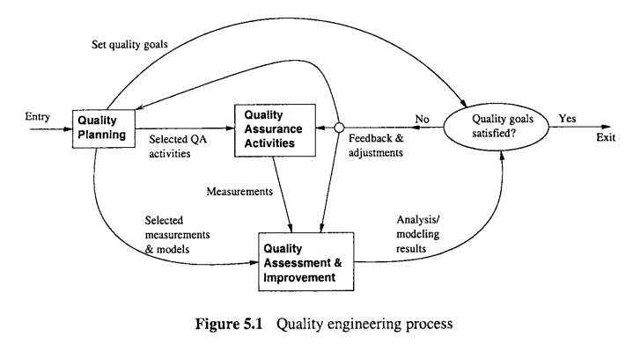

1. **Pre-QA activities:** **Quality planning.** These are the activities that should be carried out before carrying out the regular QA activities. There are two major types of pre-QA activities in quality planning, including:
   1. Set specific quality goals.
   2. Form an overall QA strategy, which includes two sub-activities:
      1. Select appropriate QA activities to perform.
      2. Choose appropriate quality measurements and models to provide feedback, quality assessment and improvement.
2. **In-QA activities: Executing planned QA activities and handling discovered defects.** In addition to performing selected QA activities, an important part of this normal execution is to deal with the discovered problems.
3. **Post-QA activities: Quality measurement, assessment and improvement.** These are the activities that are carried out after normal QA activities have started but not as part of these normal activities. The primary purpose of these activities is to provide quality assessment and feedback so that various management decisions can be made and possible quality improvement initiatives can be carried out.